EXERCISE NO : 8

DATE : 23/11/2020

AIM :

To write a python program to get a list , sorted in increasing order by the last element in each tuple from a given list of non empty tuples.

PROGRAM :

lst=[]

list1=int(input("Enter no. of elements:"))

for x in range(0,list1):

val=int(input())

lst.append((val,pow(val,3)))

lst1=sorted(lst)

print(lst)

print(lst1)

OUTPUT:

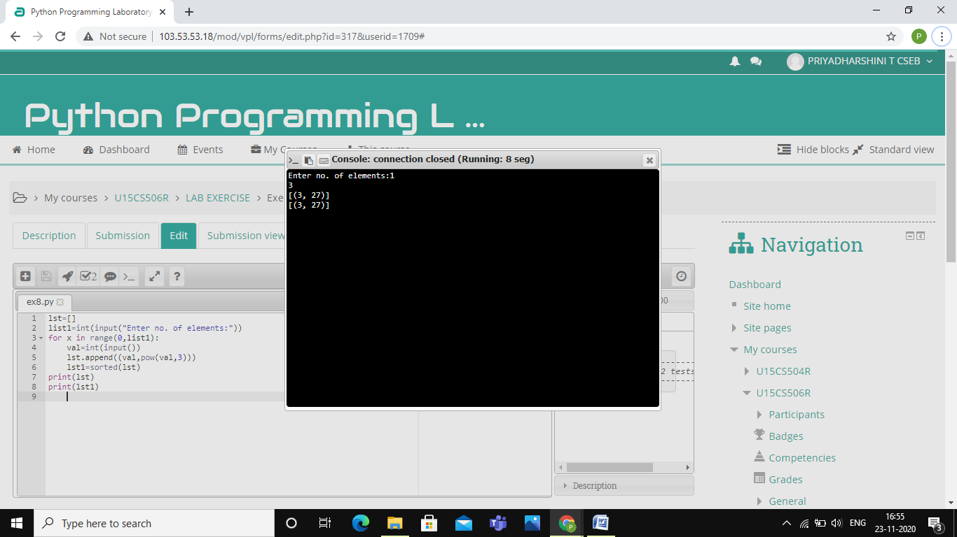

LINK :

<http://103.53.53.18/mod/vpl/forms/edit.php?id=317&userid=1709#>

RESULT :

Thus , the program is successfully executed and the output is verified.